Mallela Seshagiri
22beccs29
https://drive.google.com/file/d/1jJe-qFdLz7TtFNqOnHT4iWqxEoJtjDsI/view?usp=drive_link
1. Introduction
Cloud computing provides on-demand access to servers, storage, and applications over the internet, removing the necessity for physical hardware. Amazon Web Services (AWS) is a leading cloud platform, and its EC2 (Elastic Compute Cloud) core service allows users to launch and manage virtual servers.

2. Procedure

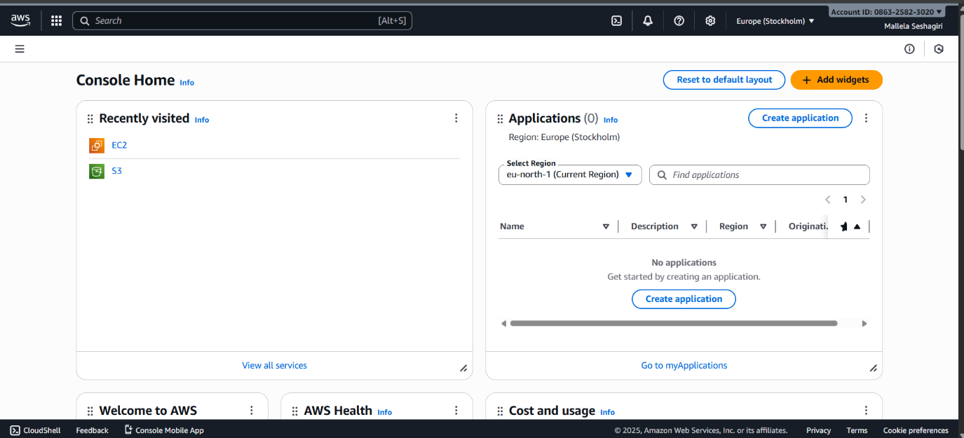
Step 1: Launching and Configuring the AWS EC2 Instance
The virtual server was configured and launched using the following specifications:
- Open AWS Console: Navigated to the EC2 Dashboard and clicked Launch Instance.
- OS Selection (AMI): The Ubuntu 22.04 LTS AMI was chosen as the operating system.
- Instance Type: The t3.micro instance type was selected to remain within the AWS Free Tier limits.
- Key Pair Creation: A new key pair named Portfolio.pem was created, downloaded, and securely saved for SSH authentication.
- Security Group Configuration: The Security Group was set up to permit the required inbound traffic:
  - Port 22 (SSH): Allowed terminal access using the key pair.
  - Port 80 (HTTP): Allowed web traffic from 0.0.0.0/0 (the entire internet) for public website accessibility.
- Launch and IP Note: The instance was launched, and its assigned Public IPv4 Address (e.g., 13.53.40.77) was noted.

Step 2: Connecting and Transferring Files
A local machine (Windows PC) was used to connect to the server and upload the required files:
- Fixing Key Permissions: Security permissions on the private key were corrected in the local terminal to prevent the Permission denied (publickey) error:
  - icacls Portfolio.pem /inheritance:d
  - icacls Portfolio.pem /grant:r "%username%":r
- Connecting via SSH: The secure shell connection was established using the following command:
  - ssh -i Portfolio.pem ubuntu@16.171.30.101
- Transferring the Image: The profile picture was securely copied to the EC2 instance using SCP (Secure Copy Protocol) and renamed to the web-friendly name profile.jpg:
  - scp -i Portfolio.pem "Picsart_25-03-15_11-37-07-515 (2).jpg" ubuntu@13.53.40.77:/home/ubuntu/site/profile.jpg

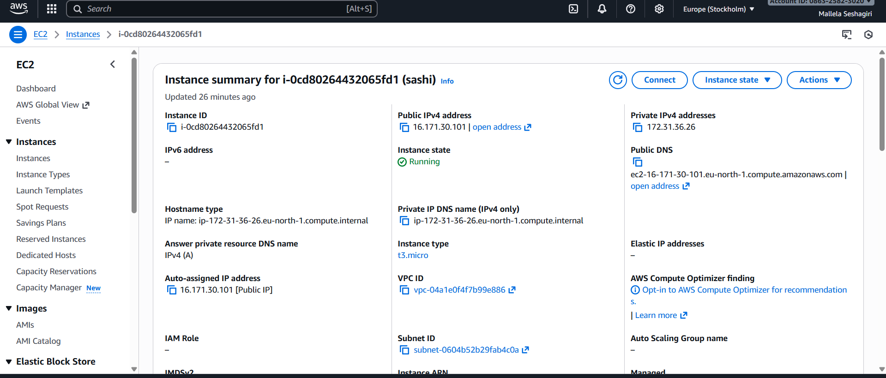
Step 3: Creating the Webpage and Starting the Server
The server was prepared to host the custom portfolio page:
- Create Directory and Navigate: A dedicated folder for the website was created on the server:
  - mkdir ~/site
  - cd ~/site
- Create/Edit HTML: The index.html file was created and edited using the nano editor. The image path in the custom portfolio code was corrected to the relative file name:
  - <img src="profile.jpg" alt="Mallela Seshagiri Profile" class="profile-img">
- Start Python HTTP Server: A lightweight Python module was used to start a web server on the publicly open Port 80, placing the process in the background (&):
  - sudo python3 -m http.server 80 --bind 0.0.0.0 &
- Verification: The website was successfully accessed via its public IP: http://13.53.40.77/, confirming the entire portfolio, including the profile picture, was loading correctly.

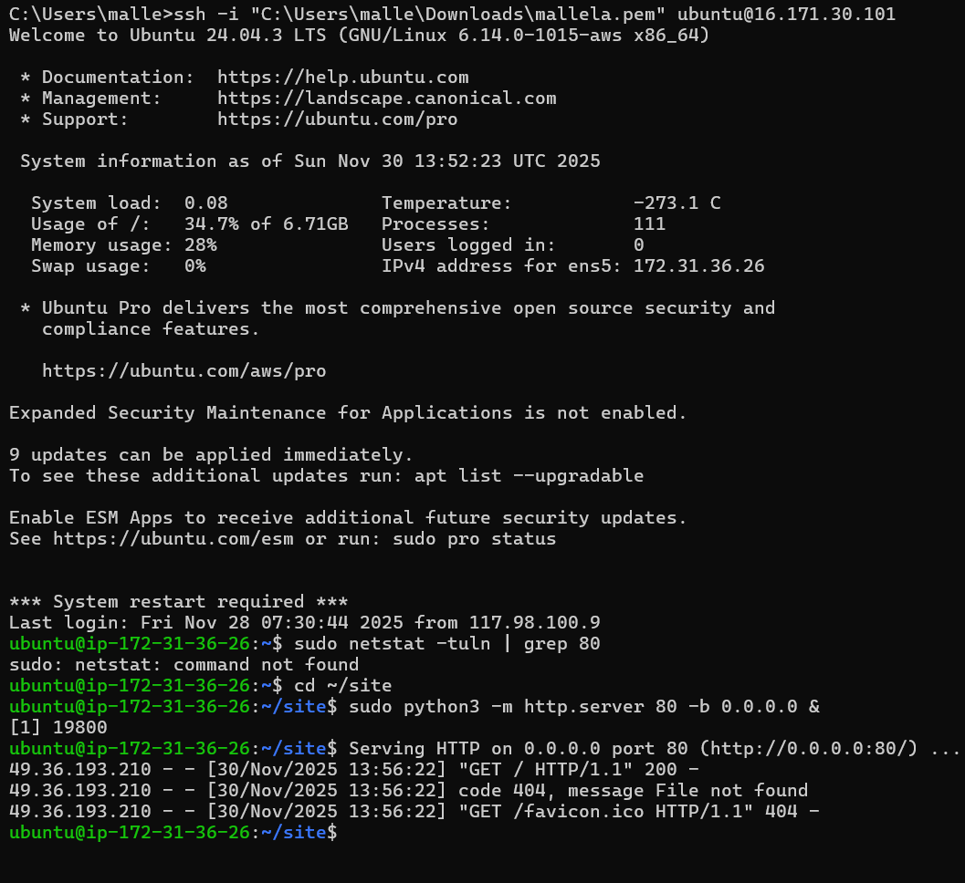
Step 4: Instance Management and Stopping
To manage cloud resources efficiently and control costs, the processes and the instance were shut down.
- Stop Python Server: The running HTTP server process was terminated using the pkill command:
  - sudo pkill -f "http.server"
- Stop EC2 Instance: The instance was stopped in the AWS Console to prevent unnecessary charges:
  - AWS Console: Instances → Select Instance → Actions → Instance State → Stop Instance.

3. Conclusion
This experiment successfully demonstrated the technical and resource management procedures for cloud deployment. All stated learning objectives regarding AWS EC2 and cloud resource management were achieved by launching a virtual server, resolving technical issues, hosting a custom website, and critically stopping the unused instance for cost control.
